Adding thread group to the test plan and given loop =10

Adding throught put controller to the threadgroup and given value =5 and based on total execution.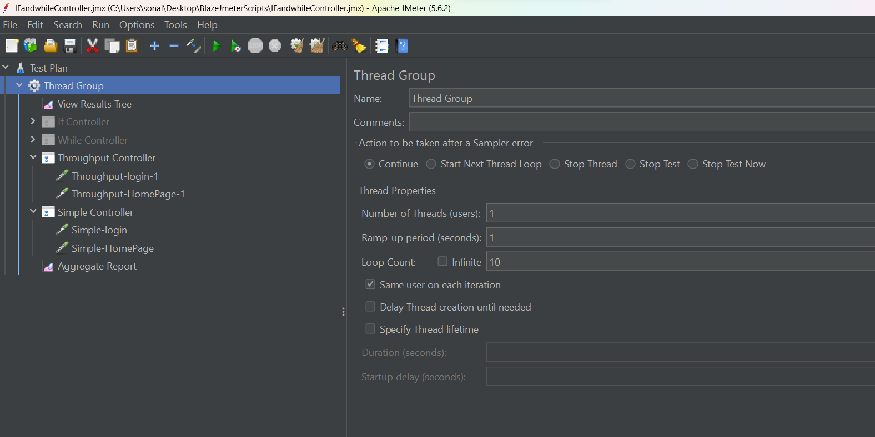

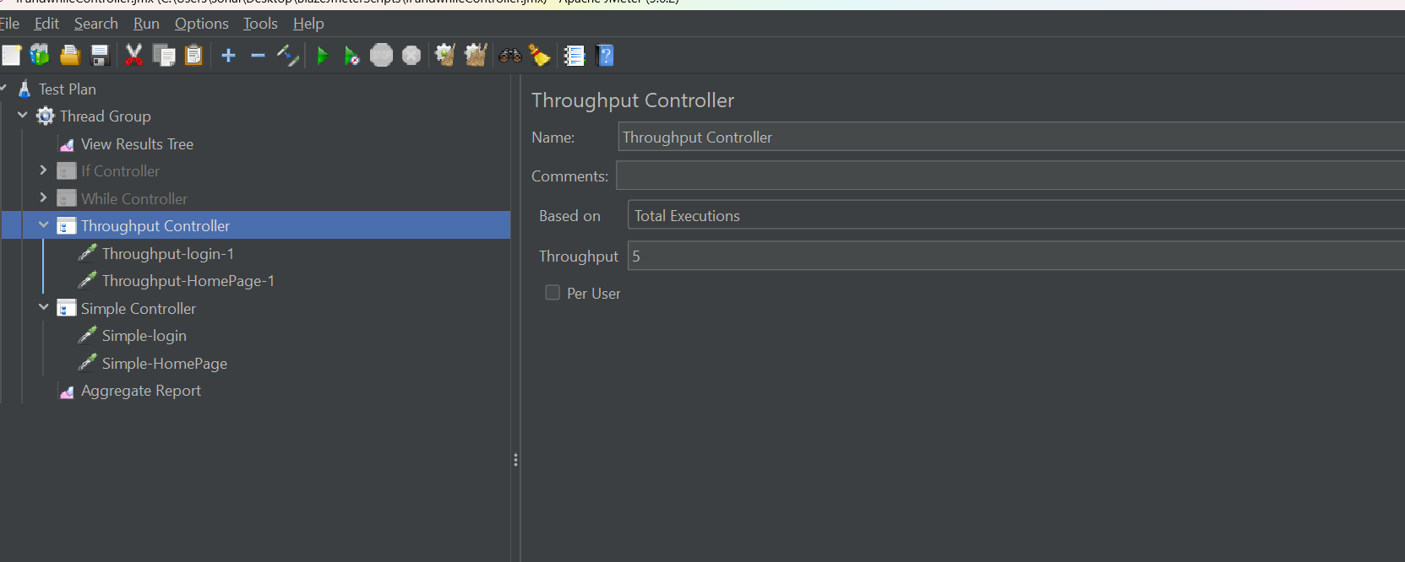

Click on run button to run

